**Easier Area of plane figures**

**1.** If $AC∥EB, ∠ABD=90°, AB=6,CD=5$, find the area of $∆ACE$.

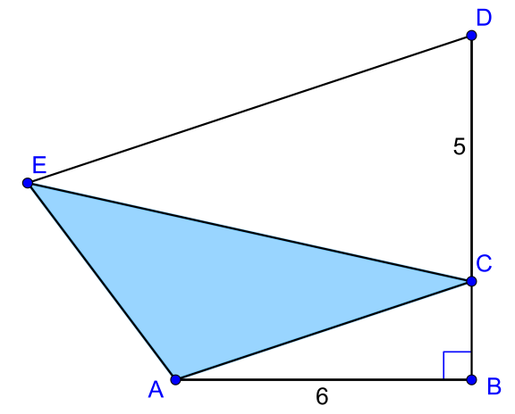

**2.** Two rectangles $ABCD,BEFG$ of dimensions $4×5, 6×7$ respectively are given.

Find the shaded area $AFGCH$.

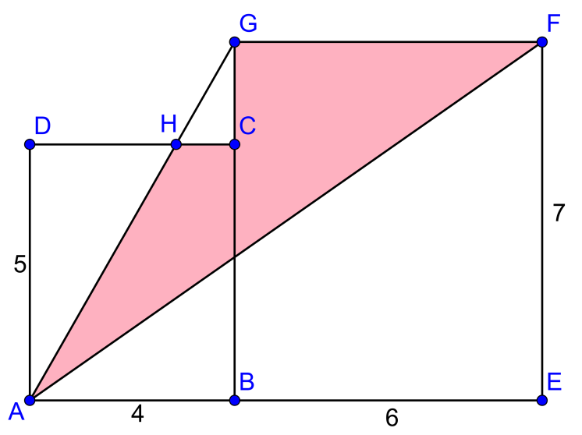

**3.** If $GH∥LK, ∠IGH=90°, GH=x,GI=y,LK=z$,   
 find the area of trapezium $GHKL$ in terms of $x,y and z$.

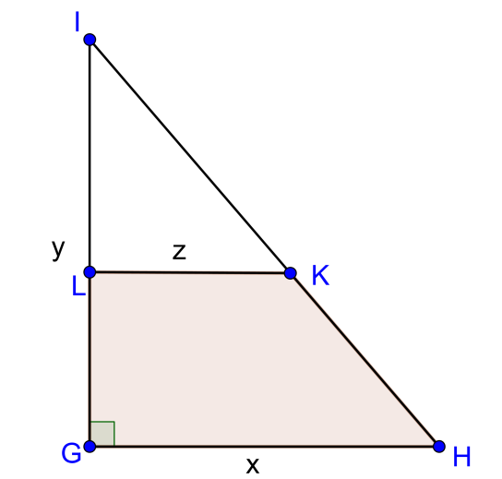

**4.** If $∆PQR$ is equilateral and $PMNR$ is a square. Each side of the square is of unit 1,

$PM$ cuts $QR$ at $S$, find the area of $∆QNS$.

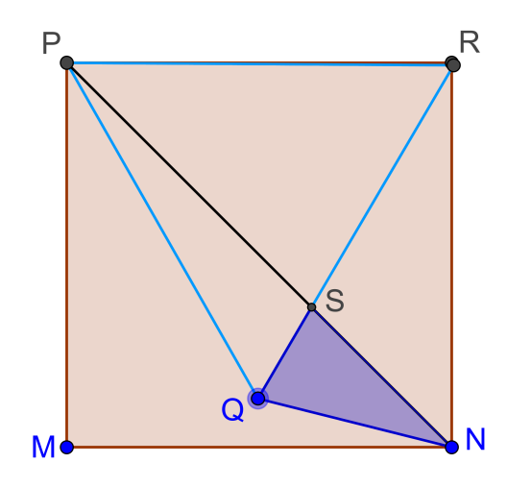

**5.** If $TUVW$ is a square of sides 7, $UZ=4$, $WU$ cuts $TZ$ at $X$, find the area of $VWXZ$.

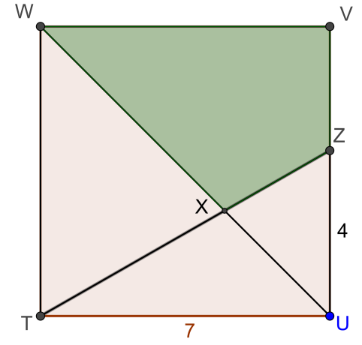

**6. (Quickie)** Given a triangle $∆ABC$ right angled at $A$. If $BC=11$ and the altitude from $A$ to $BC$ is $6$. Find the area of the triangle.

**Denote $\left[∆ABC\right]$ be the area of $∆ABC$.**

**1. $\left[∆ACE\right]=\left[∆ACD\right], same base AC$** , same height between parallel lines.

$=\frac{1}{2}×5×6=\underline{\underline{15}}$

**2. $CG=7-5=2$**

$∆HCG\sim ∆ABG⟹\frac{HC}{AB}=\frac{GC}{GB}⟹\frac{HC}{4}=\frac{2}{7}⟹HC=\frac{8}{7}$

$\left[∆HCG\right]=\frac{1}{2}×2×\frac{8}{7}=\frac{8}{7}$

$\left[AFGC\right]=\left[∆AFG\right]-\left[∆HCG\right]=\frac{1}{2}×4×7-\frac{8}{7}=\underline{\underline{\frac{90}{7}}}$

**3.** Let $LG=w$

$∆ILK\sim ∆IGH⟹\frac{IL}{IG}=\frac{LK}{GH}⟹\frac{y-w}{y}=\frac{z}{x}⟹w=y\left(\frac{x-z}{x}\right)$

$\left[GHKL\right]=\frac{1}{2}×\left(x+z\right)×y\left(\frac{x-z}{x}\right)=\frac{y\left(x+z\right)\left(x-z\right)}{2x}$

**4. $PM=MN=NP=RP=PQ=QR=1$**

$∠PRQ=60°,∠SRN=30°,∠SNR=45°$

|  |  |
| --- | --- |
| **Method 1**  Let h be the length of the perpendicular from S to NR. $$\frac{h}{\tan{30°}}+\frac{h}{\tan{45°}}=1$$ $h\sqrt{3}+h=1$ $h=\frac{1}{\sqrt{3}+1}=\frac{\sqrt{3}-1}{2}$ $\left[∆SNR\right]=\frac{1}{2}×1×\left(\sqrt{3}-1\right)=\frac{\sqrt{3}-1}{4}$ | **Method 2 $$∠RSN=180°-30°-45°=105°$$**  By Sine Law on $∆SNR$, $\frac{SR}{\sin{45°}}=\frac{1}{\sin{105°}}$ $SR=\frac{\sin{45°}}{\sin{105°}}=\frac{\sin{45°}}{\sin{75°}}=\frac{\sin{45°}}{\sin\left(45°+30°\right)}$ $=\frac{\sin{45°}}{\sin{45°cos30°+cos45°sin30°}}=\frac{\frac{1}{\sqrt{2}}}{\frac{1}{\sqrt{2}}\frac{\sqrt{3}}{2}+\frac{1}{\sqrt{2}}\frac{1}{2}}$ $=\frac{2}{\sqrt{3}+1}=\sqrt{3}- 1$ $\left[∆SNR\right]=\frac{1}{2}SR×RNsin ∠SRN$ $=\frac{1}{2}\left(\sqrt{3}-1\right)sin30°=\frac{\sqrt{3}-1}{4}$ |

$∴\left[∆SQN\right]=\left[∆SQN\right]-\left[∆SNR\right]=\frac{1}{2}×1×1×sin30°-\frac{\sqrt{3}-1}{4}=\frac{2-\sqrt{3}}{4}$

**5. $\left[∆VWZ\right]=\frac{1}{2}×3×7=\frac{21}{2}$**

$∆XWT\sim ∆XUZ⟹\frac{TX}{XZ}=\frac{WT}{UZ}⟹\frac{TX}{XZ}=\frac{7}{4}⟹\frac{ \left[∆XTW\right]}{ \left[∆XZW\right]}=\frac{7}{4}⟹\left\{\begin{aligned}\left[∆XTW\right]=7k \\ \left[∆XZW\right]=4k\end{aligned}\right.$

$\left[∆TWZ\right]=\frac{1}{2}×7×7=\frac{49}{2}$

$$\left[∆XTW\right]+\left[∆XZW\right]=\left[∆TWZ\right]⟹7k+4k=\frac{49}{2}$$

$$k=\frac{49}{22}$$

$$\left[∆XZW\right]=4k=\frac{98}{11}$$

$\left[VWXZ\right]=\left[∆XZW\right]+\left[∆VWZ\right]=\frac{98}{11}+\frac{21}{2}=\underline{\underline{\frac{427}{22}}}$

**6.** The answer is **not $\frac{1}{2}×11×6=33$** **.**

Draw a circle with BC as diameter. Then point A is a point on the circumference of the circle. (The theorem Angle in semi-circle ensures $∠BAC$ is right angle.) The maximum altitude drawn from A to BC is then the radius of the circle in which $∆ABC$ is isosceles.

However, the radius is $\frac{11}{2}=5.5<6$. So there is **no possible solution**.