**Beer problem**

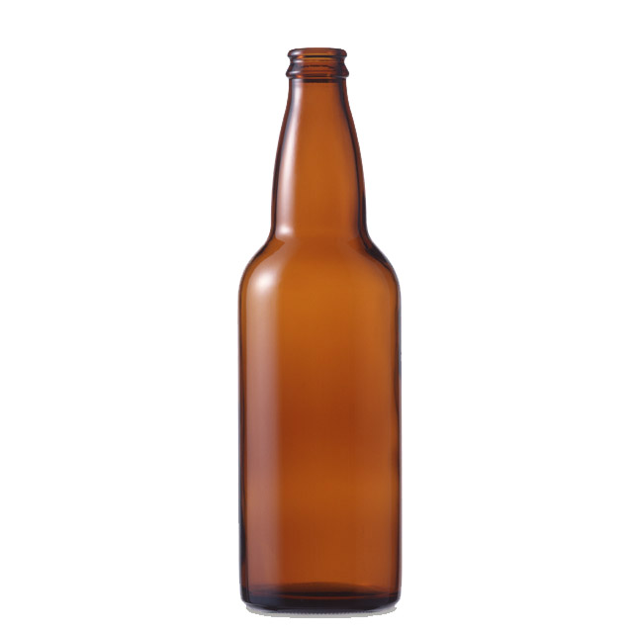

A beer provider determines to give away free beer in its 100 anniversary. For every beer, you have an empty bottle and a cap after drinking. You can redeem an extra bottle of beer for every 2 bottles or 4 caps from the provider.

1. Suppose you have 10 bottles of beer, how many bottles of beer altogether (including the originally 10) you can drink?
2. Find f(n), the total number of bottles of beer if originally you have n bottles.

**Note:** You are **not** allowed to borrow empty bottles or caps from others.

You may use EXCEL or other software to help you to get f(n).

You only need to provide the answers and not the lengthy logics behind.

**Answers:**

1. 35
2. f(n) = 4n – 5

Link of small EXCEL program: [http://www.qc.edu.hk/math/Small%20problems/Beer.xlsx](Beer.xlsx)

**Yue Kwok Choy**

**27/6/2016**