**Mooncakes**



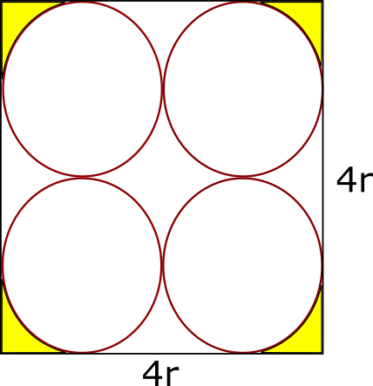

**(a)** A square box of side $d$ contains 4 moon-cakes each of radius $r$ is shown in the right diagram.

Find the area shaded in yellow in terms of $d$.

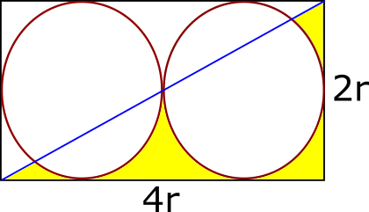**(b)** **(i)** A rectangular moon-cake box contains two moon-cakes, each of radius r.

A diagonal is drawn as shown in the right.

Find the total area of the parts shaded yellow in terms of r.

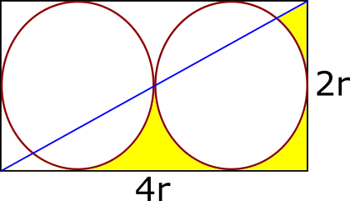 **(ii)** Find the total area of the parts shaded yellow in terms of r.

(Note that a small piece of area in yellow in the lower left corner is removed)

**(a)** The area shaded in yellow $=\frac{4}{16}\left(d^{2}-4r^{2}\right)=\frac{1}{4}\left[d^{2}-4{\left(\frac{d}{4}\right)}^{2}\right]=\underline{\underline{\frac{3 d^{2}}{16}}}$

**(b) (i)**

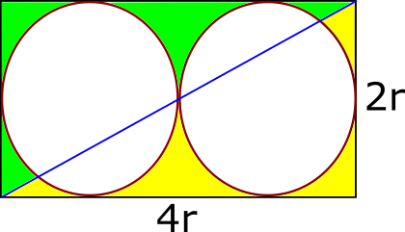

Total area shaded in yellow = total area shaded in green

Therefore, total area shaded in yellow

$$=\frac{1}{2}\left[area of rectangle-2\left(area of one circle\right)\right]$$

$$=\frac{1}{2}\left[\left(4r\right)\left(2r\right)-2\left(πr^{2}\right)\right]=4r^{2}-πr^{2}=\underline{\underline{\left(4-π\right)r^{2}}}$$

**(b)** **(ii)** We concentrate on the left square and find the lower left area that is removed.

(in green)

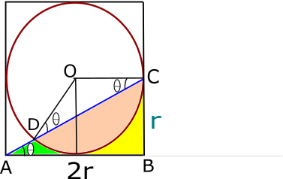

Area in green = area of ΔABC – area in yellow – area in orange

Area of ΔABC $=\frac{1}{2}×2r×r=r^{2}$

Area in yellow $=\frac{1}{4}×\left(area of square-area of circle\right)$

$=\frac{1}{4}×\left(4r^{2}-πr^{2}\right)=\frac{1}{4}\left(4-π\right)r^{2}$

$∠BAC=θ$, then $∠OCD=∠ODC=θ$, $∠DOC=π-2θ$

$\tan{θ=\frac{CB}{AB}=\frac{r}{2r}}=\frac{1}{2}$

Also by Pythagoras Theorem, $AC=\sqrt{5}r$, $\sin{θ=\frac{r}{\sqrt{5}r}}=\frac{1}{\sqrt{5}}, \cos{θ}=\frac{2r}{\sqrt{5}r}=\frac{2}{\sqrt{5}}$

Area of ΔDOC $=\frac{1}{2}r^{2}\sin\left(π-2θ\right)=\frac{1}{2}r^{2}\sin{2θ=\frac{1}{2}r^{2}\left(2 sin θ cos θ\right)}$

$=\frac{1}{2}r^{2}\left(2 ×\frac{1}{\sqrt{5}}× \frac{2}{\sqrt{5}}\right)=\frac{2}{5}r^{2}$

Area of segment in orange = Area of sector – area of ΔDOC

$=\frac{1}{2}r^{2}\left(π-2θ\right)-\frac{2}{5}r^{2}=\frac{1}{2}{πr}^{2}-\frac{2}{5}r^{2}-r^{2}θ=\frac{1}{2}{πr}^{2}-\frac{2}{5}r^{2}-r^{2}\tan^{-1}{\frac{1}{2}}$

Area in green = area of ΔABC – area in yellow – area in orange

$r^{2}-\frac{1}{4}\left(4-π\right)r^{2}-\left(\frac{1}{2}{πr}^{2}-\frac{2}{5}r^{2}-r^{2}\tan^{-1}{\frac{1}{2}}\right)=\frac{2 r^{2}}{5}{-\frac{π r^{2}}{4}+r}^{2}\tan^{-1}{\frac{1}{2}}$

Lastly, the total area of the parts shaded yellow

= area in part (a) - missing small piece of area in green calculated above

$=\left(4-π\right)r^{2}-\left[\frac{2 r^{2}}{5}{-\frac{π r^{2}}{4}+r}^{2}\tan^{-1}{\frac{1}{2}}\right]$

$=\underline{\underline{\frac{18 r^{2}}{5}-\frac{3π r^{2}}{4}-r^{2}\tan^{-1}{\frac{1}{2}}}}$

**Yue Kwok Choy**

**15/9/2016**