**Polygons**

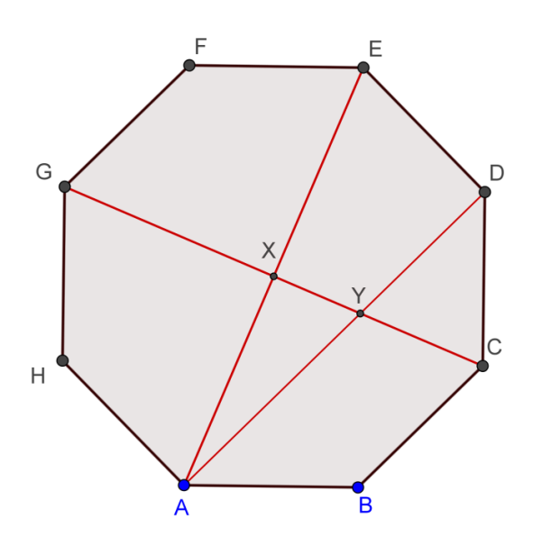**1.** (Warm-up on Pythagoras Theorem)

Given a regular octagon ABCDEFGH with

sides 2 cm.

**(a)** If AE intersects CG at X.

Find the length of AX.

**(b)** If AD cuts CG at Y.

Find the length of XY.

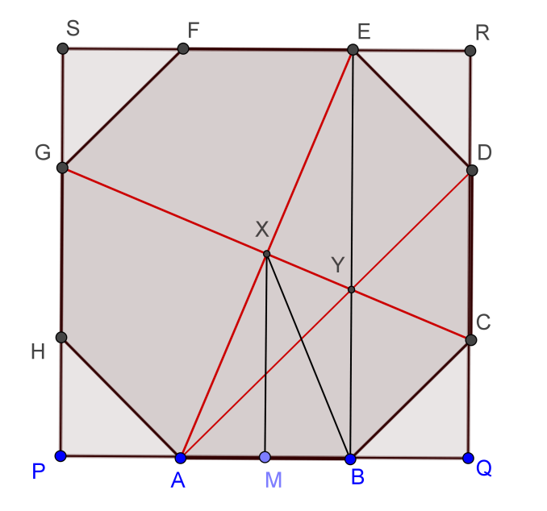

**1. (a)** Draw a square outside touching the sides of the octagon as in the diagram.

It can be seen that X is the centre of both

the octagon and the square.

By Pythagoras Theorem on $∆PAH$,

$PA=PH=\sqrt{2}$

$PQ=PA+AB+BQ=\sqrt{2}+2+\sqrt{2}$

$=2+2\sqrt{2}$

So the side of the square is $2+2\sqrt{2}$.

By Pythagoras Theorem on $∆ABE$,

$AE=\sqrt{2^{2}+{2+\left(2\sqrt{2}\right)}^{2}}=\sqrt{8 \sqrt{2}+16}$

$AX=\frac{1}{2}AE=\frac{1}{2}\sqrt{8 \sqrt{2}+16}=\sqrt{2 \sqrt{2}+4}≈2.6131259297528$**cm**

**(b)** Note that $∆ABY$ is right angled and $∠BAY=45°$.

By Pythagoras Theorem, $AY=\sqrt{8}$

Note that AE is perpendicular to CG.

Apply Pythagoras Theorem on $∆AXY$.

$XY=\sqrt{{\left(\sqrt{8}\right)}^{2}-{\left(\sqrt{2 \sqrt{2}+4}\right)}^{2}}=\sqrt{4-2 \sqrt{2}}≈1.0823922002924$**cm**

**2.** A dodecagon of is placed inside a circle of radius 1 cm, and the twelve dividing points are joined to the circle's centre, producing twelve rays. Starting from $P_{1}$ a segment is drawn perpendicular to the next ray $OP_{2}$ in the anti-clockwise sense; and from the foot of this perpendicular another perpendicular segment is drawn to the next ray, and so on forever.

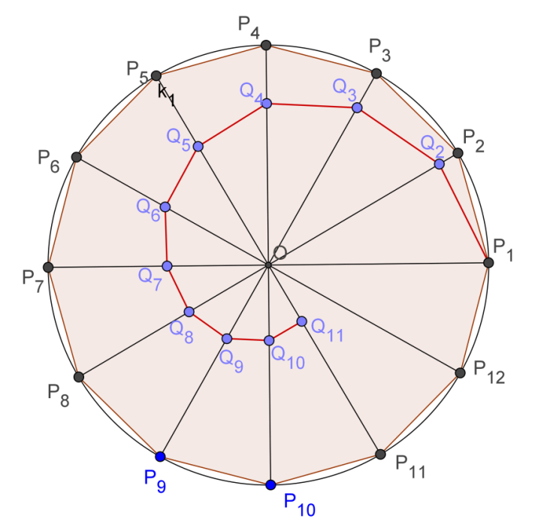 **Taking ${Q_{1}=P}_{1}$** .

**(a)** Find the limit of the sum of the lengths of these segments:

$Q_{1}Q_{2}+Q_{2}Q_{3}+Q_{3}Q_{4}+Q_{4}Q_{5}+…$

$=\sum_{k=1}^{∞}{Q_{k}Q_{k+1}}$

**(b)** Find the limit of the area of the triangles :

$∆OQ_{1}Q_{2}+∆OQ_{2}Q_{3}+∆OQ_{3}Q_{4}+…$

$=\sum_{k=1}^{∞}{∆OQ_{k}Q_{k+1}}$.

**(c)** (For more able students)

Instead of starting with the circle divided into twelve equal parts, we now to divide it into n equal parts. Let ${∠Q}_{1}OQ_{2}=α$.

**(i)** Find the sum of the lengths: $\sum_{k=1}^{∞}{Q_{k}Q_{k+1}}$

**(ii)** Find the limit of the area of the triangles : $\sum_{k=1}^{∞}{∆OQ_{k}Q_{k+1}}$

**2. (a)** Consider the triangle $∆OQ_{k}Q_{k+1}$.

$∠OQ_{k}Q_{k+1}=60°,∠Q_{k}OQ_{k+1}=30°,∠Q_{k}Q_{k+1}O=90°$

Let $OQ_{k}=r_{k}, OQ_{k+1}=r_{k+1}$.

Then $r_{k+1}=r_{k}\cos{30°}=\frac{\sqrt{3}}{2}r_{k}$

$Q_{k}Q_{k+1}=r_{k}\sin{30°}=\frac{1}{2}r_{k}$

$Q_{k+1}Q_{k+2}=\frac{1}{2}r_{k+1}=\frac{1}{2}\left(\frac{\sqrt{3}}{2}r_{k}\right)=Q_{k}Q_{k+1}\frac{\sqrt{3}}{2}$

Sum of the lengths:

$\sum_{k=1}^{∞}{Q_{k}Q_{k+1}}=Q_{1}Q_{2}+Q_{2}Q_{3}+Q_{3}Q_{4}+Q_{4}Q_{5}+…$

$=\frac{1}{2}+\frac{1}{2}\left(\frac{\sqrt{3}}{2}\right)+\frac{1}{2}{\left(\frac{\sqrt{3}}{2}\right)}^{2}+\frac{1}{2}{\left(\frac{\sqrt{3}}{2}\right)}^{3}+…$, which is an infinite geometric series

$=\frac{1}{2}\left(\frac{1}{1-\frac{\sqrt{3}}{2}}\right)$, where the common ratio $\frac{\sqrt{3}}{2}<1$.

$=\frac{1}{2-\sqrt{3}}=2+\sqrt{3}≈3.7320508075689$ cm

**(b) $OQ_{k+1}=r_{k+1}=\frac{\sqrt{3}}{2}r_{k}$**

The limit of the area of the triangles : $∆OQ_{1}Q_{2}+∆OQ_{2}Q_{3}+∆OQ_{3}Q_{4}+…$

$=\frac{1}{2}OQ_{2}×Q_{1}Q_{2}+\frac{1}{2}OQ_{3}×Q_{2}Q_{3}+\frac{1}{2}OQ_{4}×{Q_{3}Q}_{4}+…$

$=\frac{1}{2}\left(\frac{\sqrt{3}}{2}\right)\left(\frac{1}{2}\right)+\frac{1}{2}{\left(\frac{\sqrt{3}}{2}\right)}^{2}\left[\frac{1}{2}\left(\frac{\sqrt{3}}{2}\right)\right]+\frac{1}{2}{\left(\frac{\sqrt{3}}{2}\right)}^{3}\left[\frac{1}{2}{\left(\frac{\sqrt{3}}{2}\right)}^{2}\right]+\frac{1}{2}{\left(\frac{\sqrt{3}}{2}\right)}^{4}\left[\frac{1}{2}{\left(\frac{\sqrt{3}}{2}\right)}^{3}\right]+…$

$={\left(\frac{1}{2}\right)}^{2}\left(\frac{\sqrt{3}}{2}\right)+{\left(\frac{1}{2}\right)}^{2}{\left(\frac{\sqrt{3}}{2}\right)}^{3}+{\left(\frac{1}{2}\right)}^{2}{\left(\frac{\sqrt{3}}{2}\right)}^{5}+{\left(\frac{1}{2}\right)}^{2}{\left(\frac{\sqrt{3}}{2}\right)}^{7}+…$

$={\left(\frac{1}{2}\right)}^{2}\left(\frac{\sqrt{3}}{2}\right)\left(\frac{1}{1-{\left(\frac{\sqrt{3}}{2}\right)}^{2}}\right)$, where the common ratio ${\left(\frac{\sqrt{3}}{2}\right)}^{2}<1$

$=\frac{\sqrt{3}}{2}≈0.8660254037844$ cm

**(c) (i)** Consider the triangle $∆OQ_{k}Q_{k+1}$.

$∠Q_{k}OQ_{k+1}=α, ∠Q_{k}Q_{k+1}O=90°$

Let $OQ_{k}=r_{k}, OQ_{k+1}=r_{k+1}$.

Then $r_{k+1}=r_{k}\cos{α}$

$Q_{k}Q_{k+1}=r_{k}\sin{α}$

$Q_{k+1}Q_{k+2}={r_{k+1}\sin{α}=r}_{k}\sin{α}\cos{α}=Q_{k}Q_{k+1}\cos{α}$

Sum of the lengths:

$\sum_{k=1}^{∞}{Q_{k}Q_{k+1}}=Q_{1}Q_{2}+Q_{2}Q_{3}+Q_{3}Q_{4}+Q_{4}Q_{5}+…$

$=\left(\sin{α}\right)+\left(\sin{α}\right)\left(\cos{α}\right)+\left(\sin{α}\right){\left(\cos{α}\right)}^{2}+\left(\sin{α}\right){\left(\cos{α}\right)}^{3}+…$

$=\left(\sin{α}\right)\frac{1}{1-\cos{α}}=\frac{\sin{α}}{1-\cos{α}}$

**(ii)** Note that : $OQ_{k+1}=r_{k+1}=r_{k}\cos{α}$

The limit of the area of the triangles :

$∆OQ_{1}Q_{2}+∆OQ_{2}Q_{3}+∆OQ_{3}Q_{4}+…$

$=\frac{1}{2}OQ_{2}×Q_{1}Q_{2}+\frac{1}{2}OQ_{3}×Q_{2}Q_{3}+\frac{1}{2}OQ_{4}×{Q_{3}Q}_{4}+…$

$=\frac{1}{2}\cos{α}\sin{α}+\frac{1}{2}{\left(\cos{α}\right)}^{2}\left[\sin{α}{\cos{α}}\right]+\frac{1}{2}{\left(\cos{α}\right)}^{3}\left[\sin{α}{\left(\cos{α}\right)}^{2}\right]$

$$+\frac{1}{2}{\left(\cos{α}\right)}^{4}\left[\sin{α}{\left(\cos{α}\right)}^{3}\right]+…$$

$=\frac{1}{2}\sin{α}cos{α}+\frac{1}{2}{\sin{α}\left(\cos{α}\right)}^{3}+\frac{1}{2}{\sin{α}\left(\cos{α}\right)}^{5}+\frac{1}{2}{\sin{α}\left(\cos{α}\right)}^{7}+…$

$=\frac{1}{2}\sin{α}cos{α}\frac{1}{1-{\left(\cos{α}\right)}^{2}}=\frac{\sin{α}cos{α}}{2{\left(\sin{α}\right)}^{2}}=\frac{\cos{α}}{2\sin{α}}=\frac{1}{2\tan{α}}$

**Yue Kwok Choy**

**7/3/2017**