**Vector**

**(a)** Let $P$ be a point inside $∆ABC$ such that $3\overset{⃑}{PA}+2\overset{⃑}{PB}+\overset{⃑}{PC}=\overset{⃑}{0}$,

find $\left[∆PBC\right]:\left[∆PCA\right]:\left[∆PAB\right]$, where $\left[∆PAB\right]$ represents the area of the $∆PAB$.

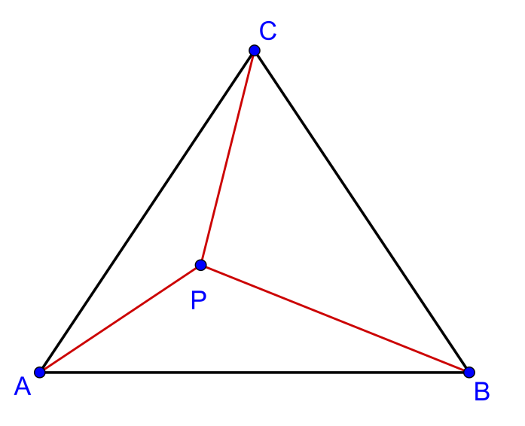

**(b)** Let $P$ be a point inside $∆ABC$ such that $a\overset{⃑}{PA}+b\overset{⃑}{PB}+c\overset{⃑}{PC}=\overset{⃑}{0}$,

find $\left[∆PBC\right]:\left[∆PCA\right]:\left[∆PAB\right]$.

**(c)** If $P$ be a point inside $∆ABC$ such that $\overset{⃑}{PA}+5\overset{⃑}{PB}+3\overset{⃑}{PC}=\overset{⃑}{0}$, find

$\left[∆ABC\right]:\left[ABPCA\right]$, where $ABPCA$ is the concave quadrilateral.

**(a)**

**Method 1**

$3\overset{⃑}{PA}+2\overset{⃑}{PB}+\overset{⃑}{PC}=\overset{⃑}{0}$

$3\left(-\overset{⃑}{AP}\right)+2\left(\overset{⃑}{AB}-\overset{⃑}{AP}\right)+\left(\overset{⃑}{AC}-\overset{⃑}{AP}\right)=\overset{⃑}{0}$

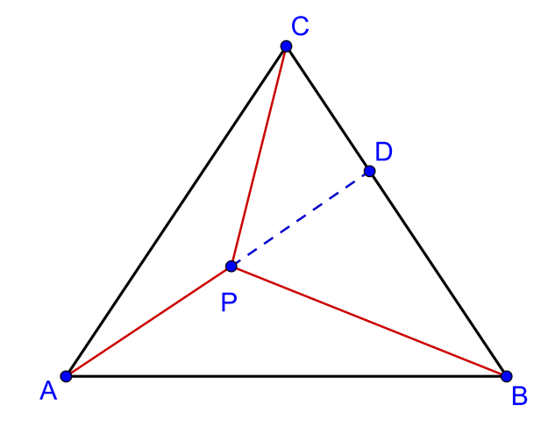 $\overset{⃑}{AP}=\frac{1}{6}\left(2\overset{⃑}{AB}+\overset{⃑}{AC}\right)$

Produce $AP$ to meet $BC$ at $D$.

Let $\overset{⃑}{AD}=λ\overset{⃑}{AP}=\frac{λ}{3}\overset{⃑}{AB}+\frac{λ}{6}\overset{⃑}{AC}$

Since $B,D,C$ are collinear, $\frac{λ}{3}+\frac{λ}{6}=1$,

$∴λ=2$

and $\overset{⃑}{AD}=\frac{2}{3}\overset{⃑}{AB}+\frac{1}{3}\overset{⃑}{AC}⟹BD:DC=1:2$

Also, $\overset{⃑}{AD}=2\overset{⃑}{AP}⟹AD=2AP⟹AP:PD=1:1$

$\left[∆PAB\right]=k$

$\left[∆PDB\right]=k$

$\left[∆ABD\right]=\left[∆PAB\right]+\left[∆PDB\right]=k+k=2k$

Since $BD:DC=1:2,$ $\left[∆PDC\right]=2k$ and $\left[∆ADC\right]=4k$

$\left[∆PBC\right]=\left[∆PDB\right]+\left[∆PDC\right]=k+2k=3k$

$\left[∆PCA\right]=\left[∆ADC\right]-\left[∆PDC\right]=4k-2k=2k$

$$∴ \left[∆PBC\right]:\left[∆PCA\right]:\left[∆PAB\right]=3k:2k:k=3:2:1$$

**Method 2**

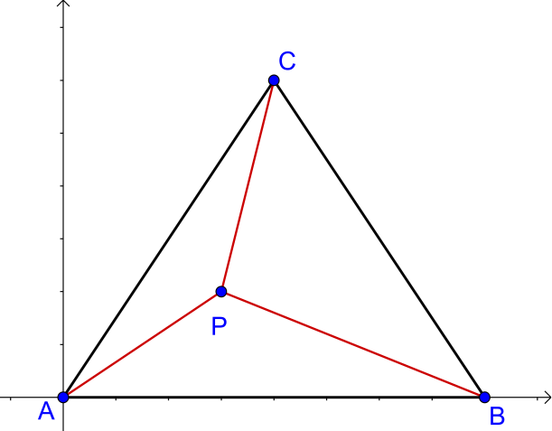

Place a coordinate system with $A$ as origin  
and $\overset{⃑}{AB}$ along x-axis.

Since $3\overset{⃑}{PA}+2\overset{⃑}{PB}+\overset{⃑}{PC}=\overset{⃑}{0}$

Consider the y-cordinates,

${-3y}_{P}-2y_{P}+\left(y_{c}-y_{P}\right)=0$

$y_{C}={6y}_{P}$

Hence, $\left[∆PAB\right]=\frac{1}{6}\left[∆ABC\right]$

If we place a coordinate system with $B$ as origin and $\overset{⃑}{BC}$ along x-axis, we get: $\left[∆PBC\right]=\frac{1}{2}\left[∆ABC\right]$

If we place a coordinate system with $C$ as origin and $\overset{⃑}{CA}$ along x-axis, we get: $\left[∆PCA\right]=\frac{1}{3}\left[∆ABC\right]$

$$∴ \left[∆PBC\right]:\left[∆PCA\right]:\left[∆PAB\right]=3:2:1$$

**Method 3**

Let $\overset{⃑}{PA^{'}}=3\overset{⃑}{PA}, \overset{⃑}{PB^{'}}=2\overset{⃑}{PB} , \overset{⃑}{PC'}=\overset{⃑}{PC }$

Then $3\overset{⃑}{PA}+2\overset{⃑}{PB}+\overset{⃑}{PC}=\overset{⃑}{0}⟹ \overset{⃑}{PA^{'}}+\overset{⃑}{PB^{'}}+\overset{⃑}{PC^{'}}=0$

Hence, $P$ is the **centroid** of the $∆A'B'C'$.

$\left[∆PB'C'\right]:\left[∆PC'A'\right]:\left[∆PA'B'\right]=1:1:1⟹\left[∆PB'C'\right]=\left[∆PC'A'\right]=\left[∆PA'B'\right]=k$

$\frac{\left[∆PBC\right]}{\left[∆PB'C'\right]}=\frac{\frac{1}{2}PB×PC×sin ∠BPC}{\frac{1}{2}PB'×PC'×sin ∠BP'C'}=\frac{\frac{1}{2}PB×PC×sin ∠BPC}{\frac{1}{2}\left(2PB\right)×PC×sin ∠BPC}=\frac{1}{2}⟹\left[∆PB'C'\right]=\frac{1}{2}k$

Similarly, $\frac{\left[∆PCA\right]}{\left[∆PC'A'\right]}=\frac{1}{3} and \frac{\left[∆PAB\right]}{\left[∆PA'B'\right]}=\frac{1}{6}⟹\left[∆PCA\right]=\frac{1}{3}k and \left[∆PA'B'\right]=\frac{1}{6}k$

$∴ \left[∆PBC\right]:\left[∆PCA\right]:\left[∆PAB\right]=\frac{1}{2}k:\frac{1}{3}k:\frac{1}{6}k=3:2:1$

**Method 4**

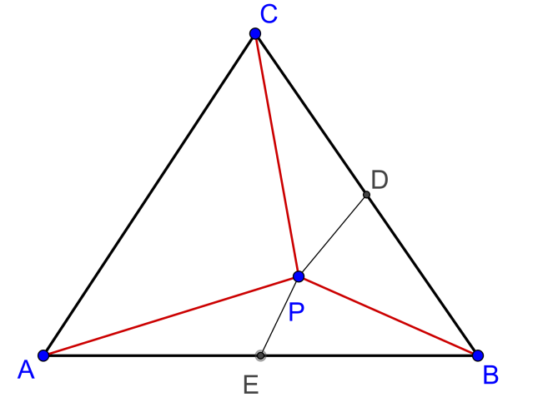

$$3\overset{⃑}{PA}+2\overset{⃑}{PB}+\overset{⃑}{PC}=\overset{⃑}{0}⟹\overset{⃑}{PB}+\overset{⃑}{PC}+2\left(\overset{⃑}{PA}+\overset{⃑}{PB}\right)=0$$

Construct the mid-point of $BC$ as $D$.

Then $\overset{⃑}{PB}+\overset{⃑}{PC}=2\overset{⃑}{PD}$

Construct the mid-point of $AB$ as $E$.

Then $\overset{⃑}{PA}+\overset{⃑}{PB}=2\overset{⃑}{PE}$

Hence we can get $2\overset{⃑}{PD}+4\overset{⃑}{PE}=0$

$$∴ \overset{⃑}{PD}=2\overset{⃑}{EP}$$

Then $D,P,E$ is a straight line and $PD:EP=2:1$

Let $\left[∆PEB\right]=k$, then $\left[∆PDB\right]=2k$

Since $D,E$ are mid-points of $BC$ and $AB$ respectively,

$\left[∆APE\right]=k,\left[∆CPD\right]=2k$

Hence $\left[∆PAB\right]=2k, \left[∆PBC\right]=4k$

By Mid-point Theorem, $AC=2ED$ and note that $∆EBD\sim ∆EDB$

Since $\left[∆EDB\right]=3k,\left[∆ABC\right]=12k$,

$$\left[∆PCA\right]=12k-4k-2k=6k$$

$∴ \left[∆PBC\right]:\left[∆PCA\right]:\left[∆PAB\right]=6k:4k:2k=3:2:1$

**Method 5** Note: $\left|\begin{matrix}x_{1} & x_{2} \\ y_{1} & y_{2}\end{matrix}\right|=x_{1}y_{2}-x_{2}y_{1}$

Let $P$ be the origin and $\overset{⃑}{PA}=x_{1}i+y_{1}j$ **, $\overset{⃑}{PB}=x_{2}i+y_{2}j$, $\overset{⃑}{PC}=x_{3}i+y_{3}j$**

$$3\overset{⃑}{PA}+2\overset{⃑}{PB}+\overset{⃑}{PC}=\overset{⃑}{0}⟹\left(3x_{1}+2x_{2}+x_{3}\right)i+\left(3y_{1}+2y_{2}+y_{3}\right)j=0$$

$$⟹\left\{\begin{aligned}3x_{1}+2x_{2}+x_{3}=0 \\ 3y_{1}+2y_{2}+y_{3}=0\end{aligned}\right.⟹\left|\begin{matrix}x_{2} & x_{3} \\ y_{2} & y_{3}\end{matrix}\right|:\left|\begin{matrix}x_{3} & x_{1} \\ y_{3} & y_{1}\end{matrix}\right|:\left|\begin{matrix}x_{1} & x_{2} \\ y_{1} & y_{2}\end{matrix}\right|=3:2:1$$

$$∴ \left[∆PBC\right]:\left[∆PCA\right]:\left[∆PAB\right]=\frac{1}{2}\left|\begin{matrix}x_{2} & x_{3} \\ y_{2} & y_{3}\end{matrix}\right|:\frac{1}{2}\left|\begin{matrix}x_{3} & x_{1} \\ y_{3} & y_{1}\end{matrix}\right|:\frac{1}{2}\left|\begin{matrix}x_{1} & x_{2} \\ y_{1} & y_{2}\end{matrix}\right|=3:2:1$$

**Method 6**

There is a one-to-one correspondence between vector and complex number.

For any vector $\overset{⃑}{v}=xi+yj$, there is a complex number $z=x+yi$.

The problem then becomes:

Take $P$ to be the origin of the complex plane and $A\left(z_{1}\right), B\left(z_{2}\right) and C\left(z_{3}\right)$, and

$3z_{1}+2z_{2}+z_{3}=0$, find $\left[∆PBC\right]:\left[∆PCA\right]:\left[∆PAB\right]$, where $\left[∆PAB\right]$ represents the area of the $∆PAB$.

Since $3z_{1}+2z_{2}+z_{3}=0$, we have the conjugate equation $3\overline{z_{1}}+2\overline{z_{2}}+\overline{z_{3}}=0$.

Hence $\left(z_{2}\overline{z_{3}}-z_{3}\overline{z_{2}}\right):\left(z_{3}\overline{z_{1}}-z_{1}\overline{z_{3}}\right):\left(z_{1}\overline{z_{2}}-z_{2}\overline{z_{1}}\right)=3:2:1$.

By the area formula in complex number, we have

$\left[∆PBC\right]:\left[∆PCA\right]:\left[∆PAB\right]=\frac{i}{4}\left|\begin{matrix}1 & 1 & 1 \\ 0 & z_{2} & z_{3} \\ 0 & \overline{z_{2}} & \overline{z_{3}}\end{matrix}\right|:\frac{i}{4}\left|\begin{matrix}1 & 1 & 1 \\ 0 & z_{3} & z_{1} \\ 0 & \overline{z_{3}} & \overline{z_{1}}\end{matrix}\right|:\frac{i}{4}\left|\begin{matrix}1 & 1 & 1 \\ 0 & z_{1} & z_{2} \\ 0 & \overline{z_{1}} & \overline{z_{2}}\end{matrix}\right|$

$=\left(z_{2}\overline{z_{3}}-z_{3}\overline{z_{2}}\right):\left(z_{3}\overline{z_{1}}-z_{1}\overline{z_{3}}\right):\left(z_{1}\overline{z_{2}}-z_{2}\overline{z_{1}}\right)$

$=3:2:1$

**(b)** Place a coordinate system with $A$ as origin and $\overset{⃑}{AB}$

along x-axis.

Since $a\overset{⃑}{PA}+b\overset{⃑}{PB}+c\overset{⃑}{PC}=\overset{⃑}{0}$

Consider the y-cordinates,

${-ay}_{P}-by_{P}+c\left(y_{c}-y_{P}\right)=0$

$y_{C}={\frac{c}{a+b+c}y}_{P}$

Hence, $\left[∆PAB\right]=\frac{c}{a+b+c}\left[∆ABC\right]$

If we set a coordinate system with $B$ as origin and $\overset{⃑}{BC}$ along x-axis, then: $\left[∆PBC\right]=\frac{a}{a+b+c}\left[∆ABC\right]$

If we set a coordinate system with $C$ as origin and $\overset{⃑}{CA}$ along x-axis, then: $\left[∆PCA\right]=\frac{b}{a+b+c}\left[∆ABC\right]$



$$∴ \left[∆PBC\right]:\left[∆PCA\right]:\left[∆PAB\right]=\frac{a}{a+b+c}:\frac{b}{a+b+c}:\frac{c}{a+b+c}=a:b:c$$

**(c) $\overset{⃑}{PA}+5\overset{⃑}{PB}+3\overset{⃑}{PC}=\overset{⃑}{0}$** , by (**b)**,

$$\left[∆PBC\right]:\left[∆PCA\right]:\left[∆PAB\right]=1:5:3$$

$\left[∆PBC\right]=k, \left[∆PCA\right]=5k, \left[∆PAB\right]=3k$

Therefore, $\left[∆ABC\right]=k+5k+3k=9k$

and $\left[ABPCA\right]=3k+5k=8k$

$\left[∆ABC\right]:\left[ABPCA\right]=9k:8k=9:8$

**Yue Kwok Choy**

**1-3-2016**

**Method 6 of part (a) added on 10-3-16**